**UI, User, and testing**

Our vision for our UI as a group was focus on Simplicity whilst completing the purpose the app was made fore. By simplifying the scope of the app, it has affected the UI and made it extremely easy to move around the interface. When building this application, we had to ask ourselves who is our scope / niche group that would be using this app. We can all fall into the stereotype of saying that people who needs care are elderly or that there not considered “Tech Wizards” and vis versa when talking about younger clients but this were we need to eliminate those stereotypes as it doesn’t help. So, by eliminating those thought we decided that the app would be focused on people are in care.

The bases of this project being the Care Tracker App is to provide a protection  and care over others and we have tried to implement that through this app by providing data such as ,  a planner that the client can use to detail there activities for the day , a help button used to signal if the client is in distress and finally a profile page detailing the clients history and telling the carer more about it client.

These bases can also be shared in the eyes off the carer themselves. Their job is to provide care to these clients and ensure their safety. This type of data has been also implemented through this app by having a tracker (this requests the client’s permission) that allows you to know where the client is when they are lost or distressed. The carer can view the clients’ planner and view the history of their client also.

The Care Tracker App is aim towards the relationship of the client and carer and these are the main users of the device. A client is as equally important to the career as to the carer to the client. They both work together to sustain a healthy balance. If you were to say who was to use the app more, I would say the client more than carer.

The only way we can determine success in this project is if the functionality that the app is and created for is fulfilled which is creating an environment to boost protection and care.

**Testing**

***How we will tell whether the project is successful or not.***

To dictate whether this project is either successful or unsuccessful, testing will be vital. The type of testing we have decided to use is user testing and usability testing. User testing is an important method to be implemented within the application. This will ensure that the project is successful and meets the functional requirements in relation to the User Interface.

Usability testing is a form of user testing which examines how the customer can use the application that we produce. User testing will be essential on both interfaces to find any usability issues.

An example of testing the UI in our project would be clicking a button and seeing if it performs the functional requirement it was given.

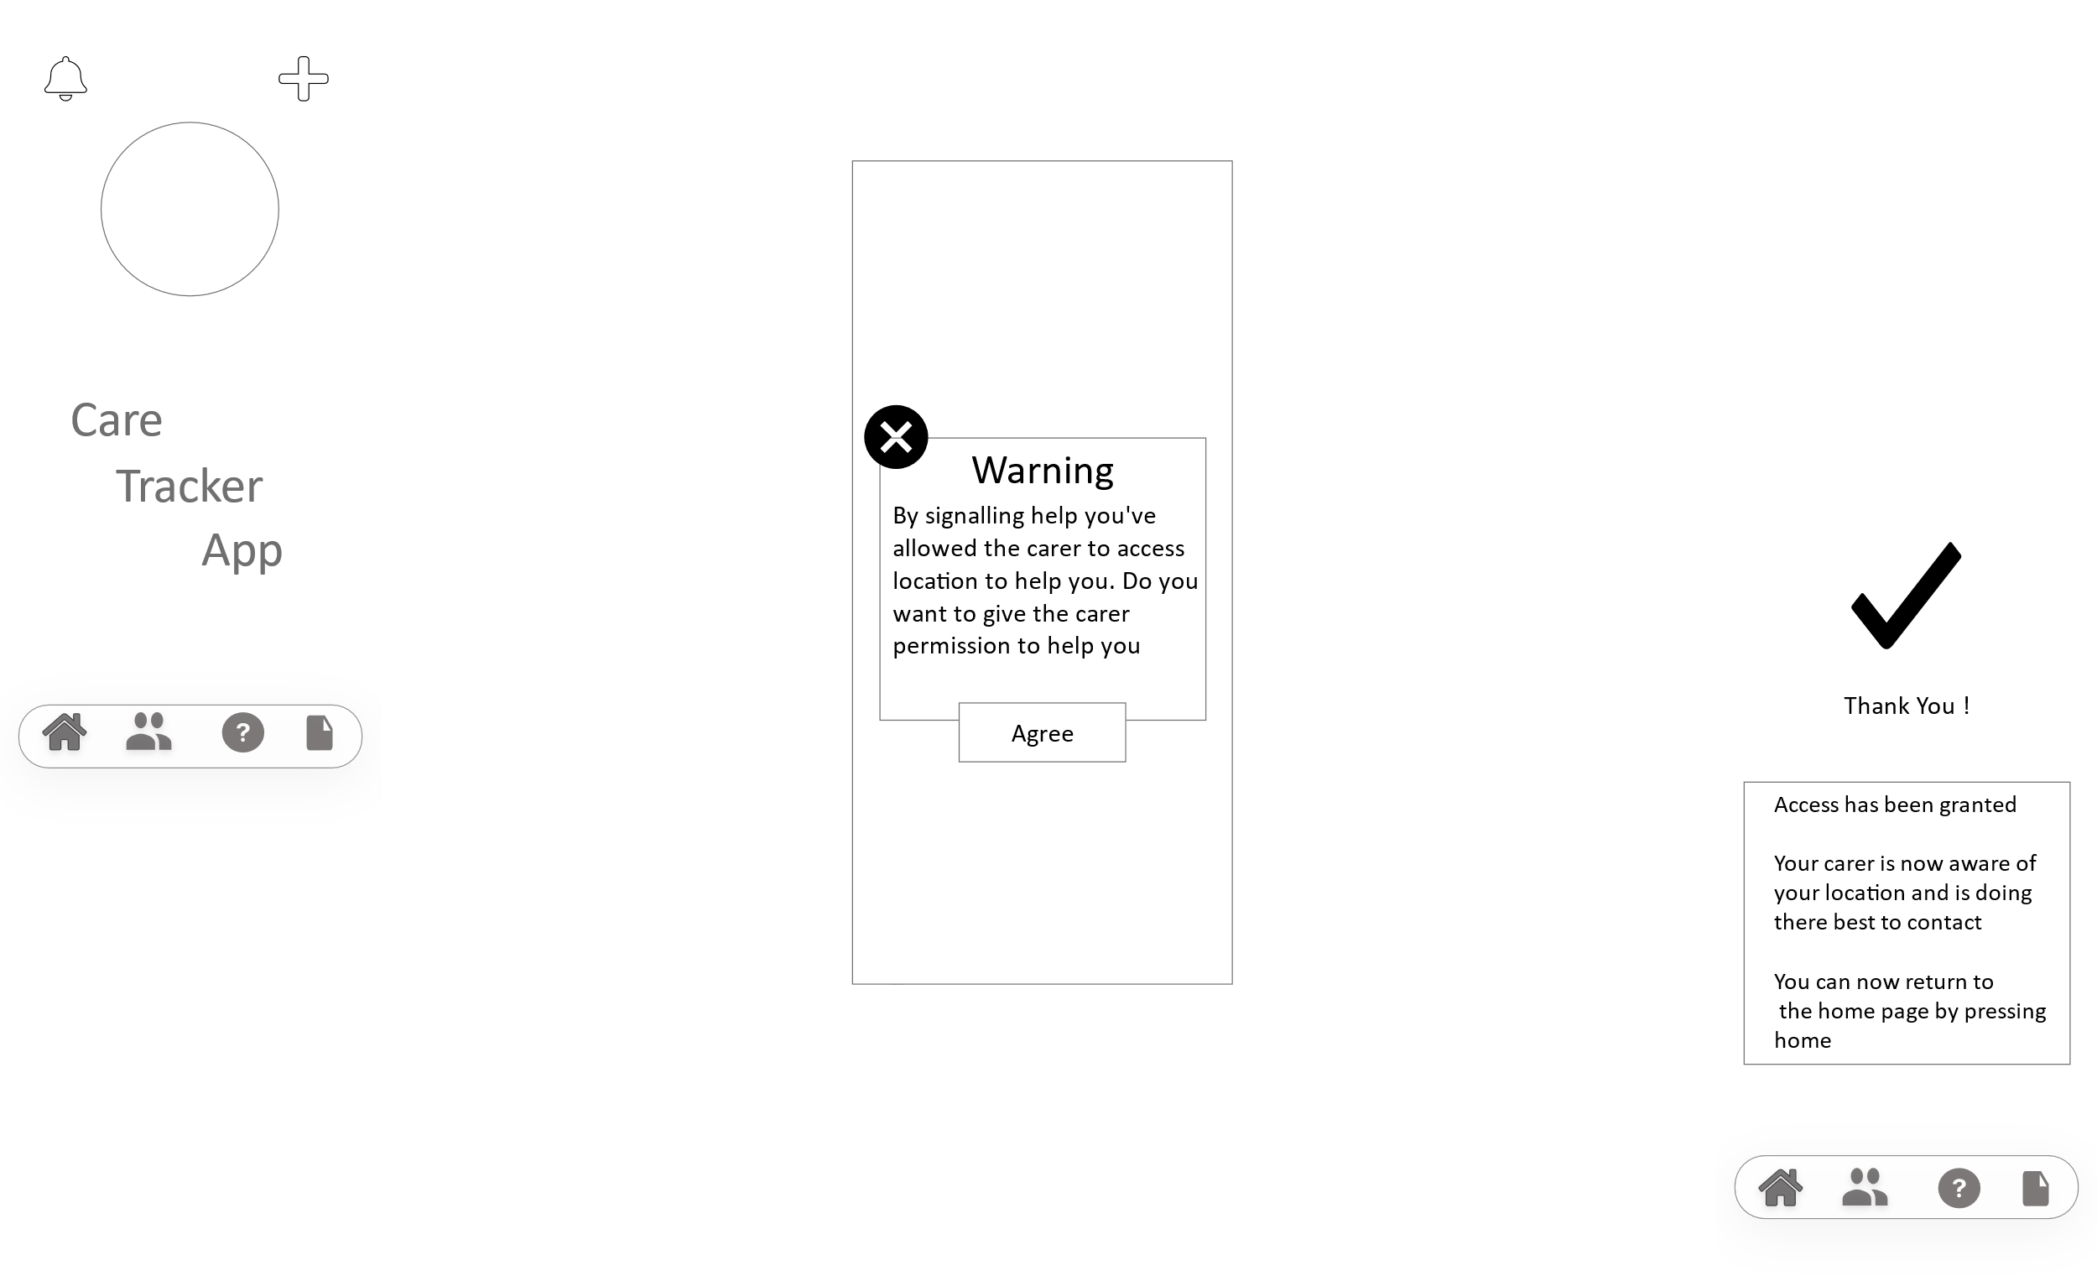

(Figure (X.X.X) – Help icon process)

In this example the diagram above shows how when the client clicks the “help” icon the purpose of the button is to alert the carer that the client may be lost or needs help. When this functionality is added in the application it will be tested to see if it does what it is meant to do. The continuous flow of testing will lead to a successful project.

The diagram below illustrates the relation between user and usability testing.

Usability Testing vs User Testing

Satisfaction

Memorability

Desirability

Credibility

Roadmap

Validation

Compatibility

Test Support Processes

(Figure. X.X.X – Relation between usability and user testing)

Our application consists of two interfaces which are illustrated in the UI design. The UI of the client side of the application has been designed to be simple and easy for the user to use. User testing will determine if this is true which will lead the application to become successful. Nevertheless, the UI of the client side has also been designed to be made easy to use, which will also be tested.

The testing of the application will begin around the middle stage of the design of the UI. The reason being is to check that features are working as they are added. By doing this time is being used wisely and will leave less issues to be resolved towards the end of the project. By carrying out user and usability testing for all features within the application, will lead to the success of the project.

Reference for diagram

( <https://www.google.com/url?sa=i&url=https%3A%2F%2Fblog.hubspot.com%2Fservice%2Fuser-testing&psig=AOvVaw1WfetmUemuIkP95sn5f-ih&ust=1605449660528000&source=images&cd=vfe&ved=0CAIQjRxqFwoTCMDGy5-cgu0CFQAAAAAdAAAAABAw> )